
Republican Women of Gregg County

Oct 2024 Newsletter: Vol 3. No. 10
Region 5 District 1

The President’s Talking Point – Jennifer Kranzman
As we are near election day I ask one question. Are you a listener or a doer for your country? Are you a member or an activist? We cannot sit back, there is too much at stake. There is so much more you can do than just vote. Think of one more patriotic thing you can do. Here are a few ideas.
- Ask your Precinct Chair if they need some help to GET THE VOTE OUT.
- Help put Trump/Vance signs and Cruz signs up everywhere and in your yard.
- Encourage people to register to vote prior to October 7th to be able to vote on November 5th.
- Volunteer to help work in the GOP office. Contact Marty Rhymes
- Post your conservative voice and values on social media.
- Make phone calls for Ted Cruz.
- Buy Trump/Vance signs from RWGC on a Saturday at the old Pier One store on the Loop.
- Anyone to be 18 by election day, just moved to Texas, or changed address needs to register.
- Be a Poll Greeter, Poll Watcher or Poll worker.
- Help put out signs at the polling station prior to early voting.
- Talking points for October is GOP POLICIES and how they differ from the Democrats policies on social media.
- Sell Trump/Vance signs to your family and friends. See Teresa Cook.
- Pray daily.


A vote for Trump is a return to common sense!
IMPORTANT ANNOUNCEMENT! OUR MONTHLY MEETING WILL BE ON THE OCTOBER 16TH AT TIA JUANITA’S AT 1501 E. MARSHALL IN LONGVIEW AT 11:30 AM. Our regular meeting place is being renovated.

Legislative Update
2024 GOP Platform

- DEFEAT INFLATION, AND QUICKLY BRING DOWN ALL PRICES.
- SEAL THE BORDER AND STOP THE MIGRANT INVASION.
- BUILD THE GREATEST ECONOMY IN HISTORY.
- BRING BACK THE AMERICAN DREAM AND MAKE IT AFFORDABLE AGAIN FOR FAMILIES, YOUNG PEOPLE, AND EVERYONE.
- PROTECT AMERICAN WORKERS AND FARMERS FROM UNFAIR TRADE.
- PROTECT SENIORS.
- CULTIVATE GREAT K-12 SCHOOLS LEADING TO GREAT JOBS AND GREAT LIVES FOR YOUNG PEOPLE.
- BRING COMMON SENSE TO OUR GOVERNMENT AND RENEW THE PILLARS OF AMERICAN
CIVILIZATION.
- GOVERNMENT OF, BY, AND FOR THE PEOPLE.
10.RETURN TO PEACE THROUGH STRENGTH.
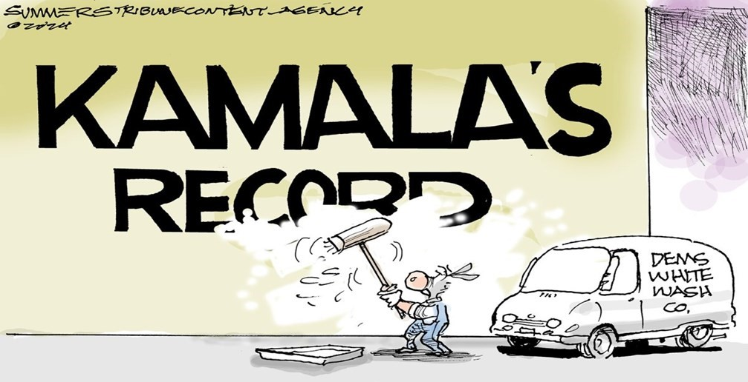


MEMBERSHIP REPORT
TRICIA OXTON – 2ND VICE PRESIDENT
“Talk is cheap, voting is free; take it to the polls.
Nanette L. Avery
October is here and the 2024 Election is only 5 weeks away. What are you going to do until the election to ensure a victory for America? Do you have a yard sign in your yard? Have you talked to your friends and family about having a VOTING PARTY or going to vote together on Election Day? Are you working the phones to get out the vote? If you need a ride to vote have you arranged for assistance? Every single one of us has the responsibility to show up and make sure the turnout is overwhelming to elect RED up and down the ticket.
We are delighted to have 7 new members join our club this past month. They are Debra Bolnick, Amy Bridges, Linda Bailey, Dia Duncan, Sandra Garrison, Marilyn Thornton and Mary Ann Verderber. We were also excited to have 32 guests attend our September membership luncheon. If any of our guests would like to join RWGC, please contact Tricia Oxton at triciaoxton@yahoo.com.
Our goal has been to have 60 members, and we met our goal and currently have 63 members and 13 associate members. We are thrilled to have reached our goal for 2024. Please invite your family and friends to attend our next membership luncheon and all the activities we have scheduled for October and beyond.
With the second assassination attempt on President Trump’s life recently, we are reminded that this is a fight between good and evil. We must do everything in our power to ensure that good wins out. Please add President Trump, Melania and their entire family to your prayer list asking God for continued divine protection and thanking God for the true miracles that have kept President Trump safe thus far.



Brenda Carlton 10-4 Mary Ann Verderber 10-8
Patricia Jeter 10-25 Michelle Terry 10-31


The ladies of the Republican Women work hard, but we also know how to have fun. We have several groups of ladies that get together on a regular basis to socialize and have an enjoyable time. These are our current groups:

Girls On the Go
This month our Girls on The Go are attending a concert featuring Rok Dox on October 3rd from 6 to 8pm at the Longview Arboretum. The concert fee is $10 per person. Bring a blanket or chair plus a snack and a drink and come fellowship with the ladies and enjoy some music! Nancy Holly facilitates this group.

Guns and Gals
Our Guns and Gals group always shoots at Top Shot Indoor Range at 11am on the first Tuesday of each month. In October, we will be meeting at the range at 11 am on October 1st. Linda Lafferty facilitates this group.

Girls Who Bowl
We are currently looking for bowlers join this group. Sharon DeHoff is the facilitator.



Pray with us every day at 12 noon. You can use these prayers or your individual thought/prayer.

Dear Father God, thank U first for the dedicated workers who love You, family and country. We petition You for a Godly and robust nation under Your authority. May U protect our elections -each worker, candidate, and voter. May fairness and legitimacy be established and may each one seek to be alert and vigilant. Our work is in Your Hands!! In Jesus we pray. Amen!
By Nancy Holly

Dear Loving, Heavenly Father.

With grateful hearts, we thank thee for the privilege to live in America. Thank you for the Prophets and inspired men who led to the forming of this great nation. We ask thee humbly, to preserve the Judeo-Christian values that have guided us for over 248 years. May our leaders and elected officials make decisions that benefit the people they represent. Bless us, Oh Lord, in our efforts to save America and protect her from evil. In the name of thy Son
and our Savior, Jesus Christ, we pray. Amen.

By Tina McIlveene

40 Days of heightened praying begins starting September 27, 2024.

Get on board!










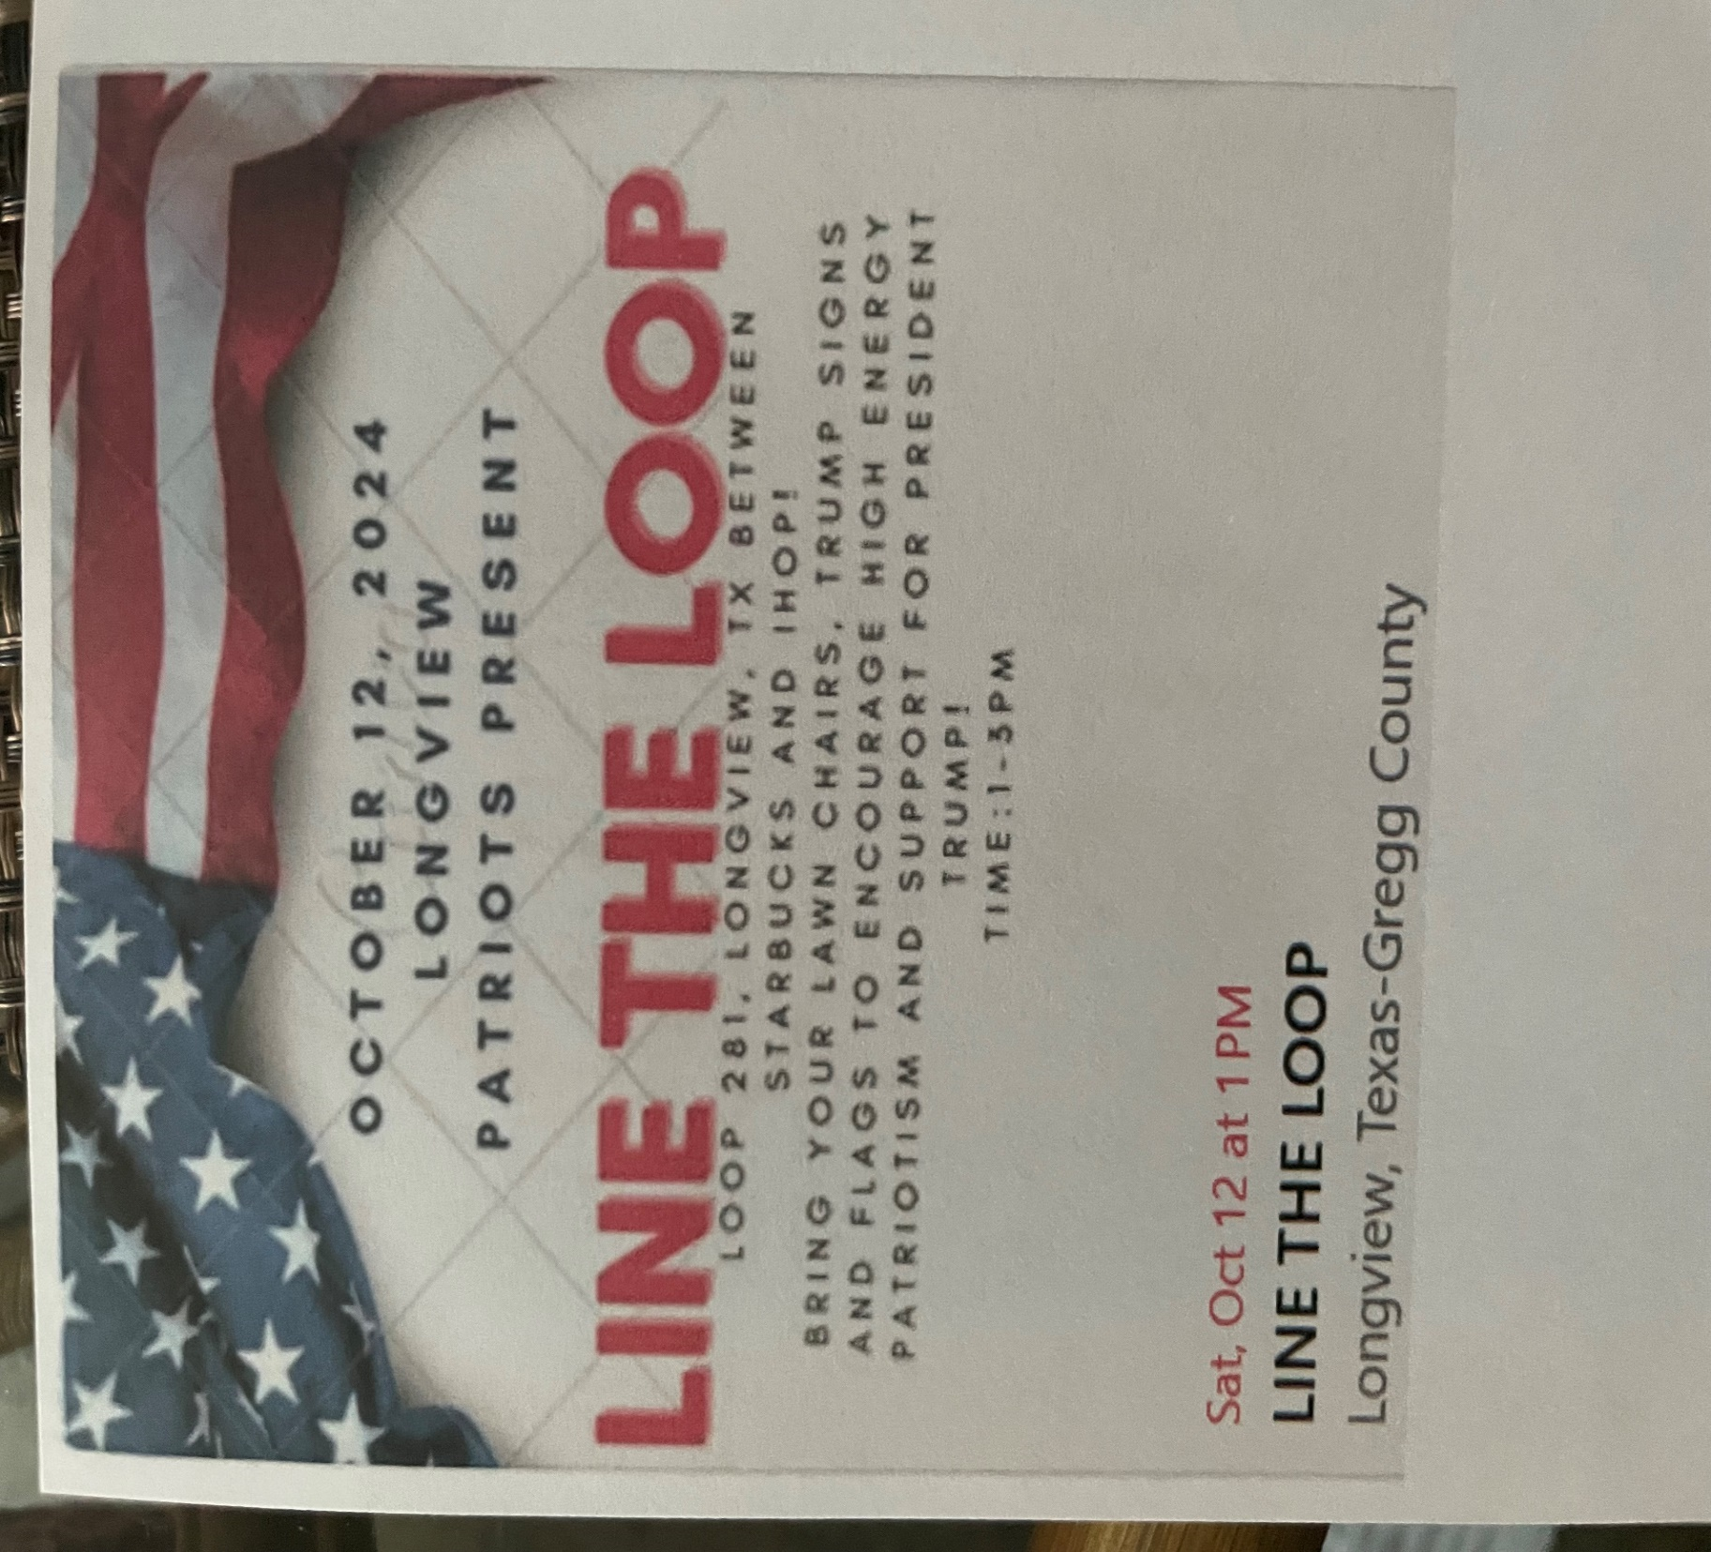
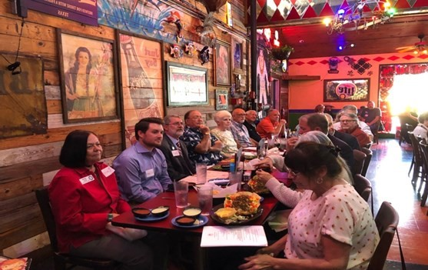
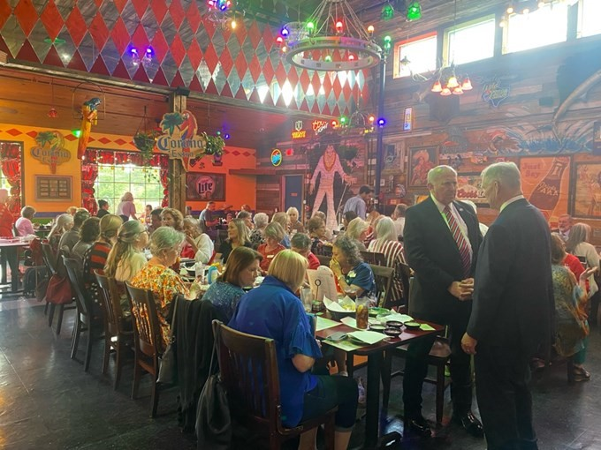
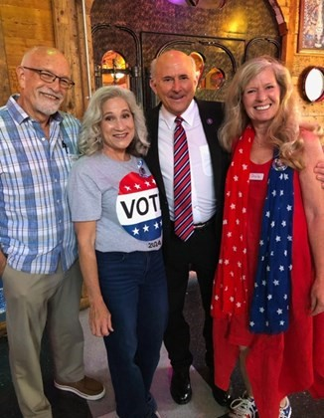
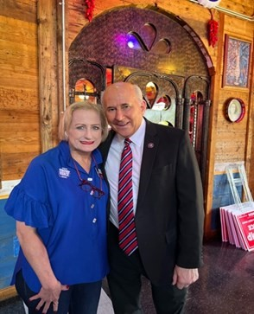
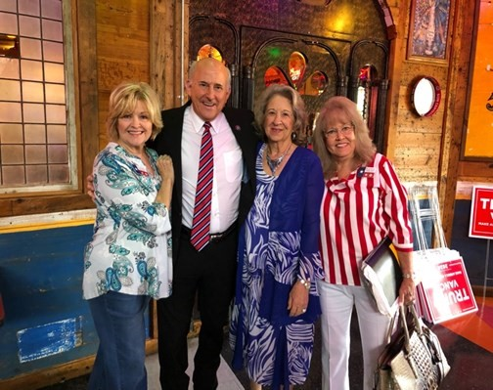

Girls On The Go at the new movie - Reagan. Everyone loved the movie!

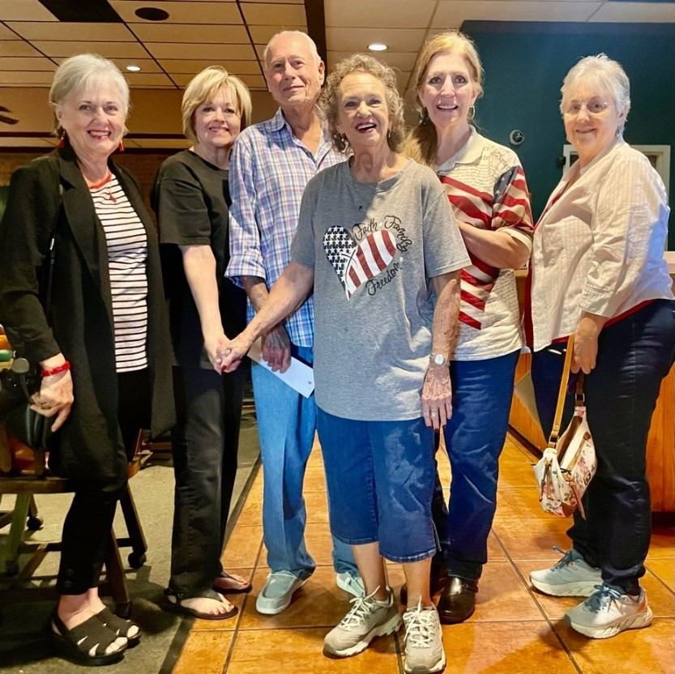

Having fun working at the GOP booth at the Gregg County Fair.
Everyone wanted to have their picture made with President Trump!

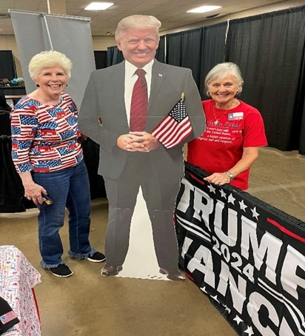
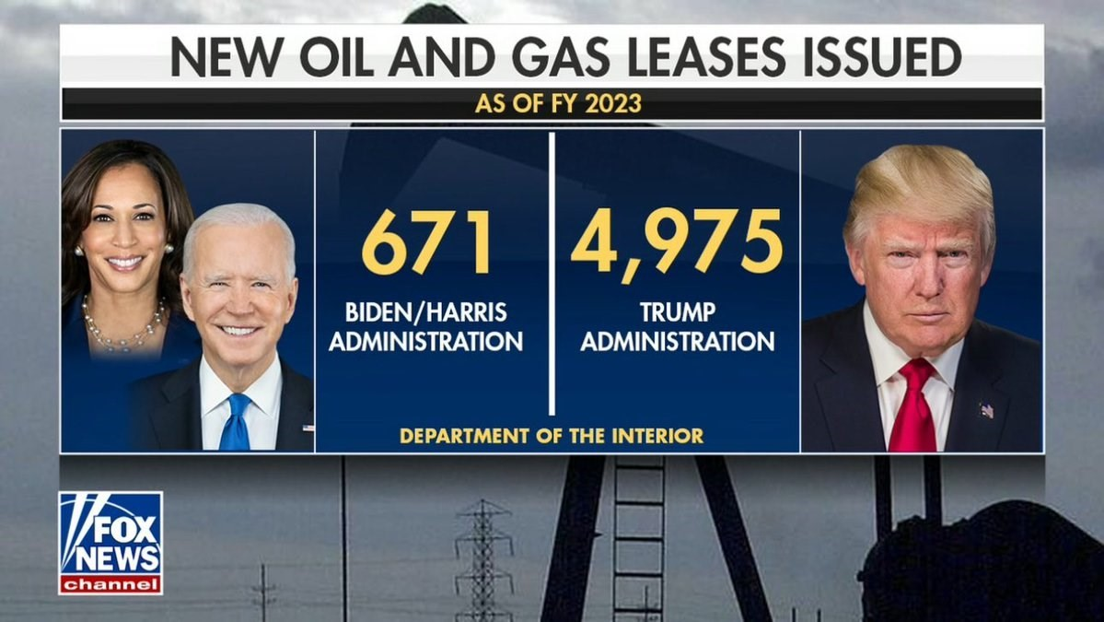




QR CODE to access our website.

IMPORTANT DATES TO REMEMBER
October 1st Guns and Gals at 11 am
October 3rd Girl On The Go to ROK DOX CONCERT at 6 pm
October 16th Monthly Membership Luncheon at TIA JUANITA’S at 11:30 am
October 17th Hillbilly Elegy Movie, GOP office, 2802 Gilmer Road, Suite 5 at 3 pm or 6 pm
October 18th Election Integrity – Senator Bob Hall at Tia Juanita’s at 6 pm
October 21st First day of Early Voting
October 25th Last day to apply for a ballot by mail in the General Election
November 1st Last day of early voting in the General Election
November 5th ELECTION DAY!
November 5th Deadline for ballot by mail to be received

KEEP THE FOLLOWING IN YOUR PRAYERS

For our nation as we go to the polls to vote for the best candidate for America
For words to encourage voters to get out and do their patriotic duty to VOTE!
For heavenly protection and intervention to keep President Trump safe
For those have medical tests, surgery, chronic pain, and family issues

Political advertising paid for by the Republican Women of Gregg County PAC. Contributions are not federal tax deductions as charitable contributions. Corporate contributions are not permitted. RWGC PAC can be contacted at P.O. Box 5, Longview, TX 75606. The information listed herein is not an endorsement of any candidate and is intended for information purposes only.

