Republican Women of Gregg County
June 2026 Newsletter: Vol. 5, No. 6
Region 5, District 1

The President’s Talking Points
Dear RWGC and Friends,
As we move into the summer months, we are reminded of how blessed we are to live in the greatest nation in the world. Across our nation, communities are preparing for the historic celebration of America’s 250th birthday. For 250 years, Americans have defended freedom, embraced opportunity and passed the torch of liberty from one generation to the next. Here in Gregg County, we are proud to be a part of the celebration. We are planning events for our Veterans, our First Responders and our community. Please join us in celebrating this special birthday.
I am excited to announce that our signature America 250 event will be our Lincoln-Reagan dinner on September 22, at Pinecrest Country Club. The special evening will bring together Republicans from across East Texas as we honor the principles that have made America exceptional. We are partnering with several conservative organizations to make this a memorable and impactful event. I encourage each of you to mark your calendars, invite friends, family members and Republicans to join us.
As President, I believe this is also a season for something greater than ourselves. While we may not always agree on every issue or strategy, we all know every successful Republican movement begins with people who are willing to work together for families, individual liberty and faith in God. Our strength is not found in uniformity; it is found in our ability to unite around our shared principles and our shared mission.
As we look ahead, we must remain focused on the work before us. We have opportunities to grow our membership, encourage new voters, support Republican candidates and ensure that Gregg County remains strong in conservative leadership. Every conversation, every volunteer hour, every new member, every event contribute to the larger effort of keeping Texas red and keeping America advancing our values. May God continue to bless each of you, the Republican Women of Gregg County, and the great state of Texas and the United States of America.
In service and friendship, Linda Bobo
President RWGC


TEXES STATE BOARD OF EDUCATION (SBOE)
Legislative Briefing – June 2026
Questions?
Melissa Beckett; 903-808-5200; melissabeckett7@gmail.com
The Texas State Board of Education is currently taking comments on the proposed Social Studies TEKS (Texas Essential Knowledge and Skills). These TEKS will directly affect what will be taught in public school classrooms in future years. In April, conservatives successfully rallied to keep the TEKS free of “positive” Islamic content lobbied by CAIR, the Islamic terrorist organization. The final vote on these TEKS will take place sometime during the week of June 22-26.

- Review the TEKS
- Provid Feedback to the SBOE
o Submit Written Comments open until 5pm June 15, 2026

  - via online form - select "Proposed New 19 TAC Chapter 113, Texas Essential Knowledge and Skills for Social Studies"
  - or email teks@tea.texas.gov
Register (June 16-19) to provide verbal testimony in Austin at the next SBOE meeting (will be sometime between June 22-26)

Please contact your SBOE Representative Kevin Ellis (512-710-7915 or ellisSBOE@gmail.com) thanking him for supporting the updated Social Studies TEKS that emphasize the influence of Christian values on the development of the United States, require teaching the dangers and attrociatrocities of Communism, and include language linking “radical Islam” to terrorism, while rejectimaking proposed language on Islamic contributions to history. Encourage him to maintain that strong stance on the final vote June.
RWGC plans to take a passenger van to Austin on the day the Social Studies TEKS will be discussed/voted on. Once the SBOE agenda is published and an exact day is known (sometime during June 22-26); we will provide more info on the passenger van for those of you interested in going.
Brad Clark has graciously agreed to be the driver! TEXAS WATER DEVELOPMENT BOARD (TWDB)
Review TEKS

Submit Written Comments for TEKS until June 15th @ 5pm

Register to provide verbal testimony in Austin
The TWDB is taking public comment on the Draft 2027 State Water Plan until 5pm Friday, May 29th. Suggested general comment: “Our country was founded on the principles of freedom and liberty. The number one job of government is to protect the rights of its people. I strongly oppose taking property/water from citizens of East Texas (Region D) to fund the future growth of the Dallas Fort Worth Area (Region C). I respectfully ask you to notify the Governor, Region C water planners and local elected officials that Region C and the State of Texas cannot handle the growth already planned, let alone possible future growth and you do not support forcing Region D to supply water to Region C as it is a violation of the fundamental rights of Texans.

FEDERAL UPDATE - KILL SWITCH STILL NEEDS REPEALED
URGENT – Massive federal government overreach needs repealed. The Biden-era “kill switch” requires vehicles manufactured after 2026 to contain advanced technology to stop vehicle operation without driver’s consent.
House – Nathaniel Moran (TX-R) joined 56 other Republicans in the House and voted against the Chip Roy (TX – R) co-authored amendment to remove the kill switch requirement.
- Contact Congressman Nathaniel Moran asking him to support any legislation or amendments that remove the Kill Switch requirement. (903-561-6349 or e-mail go to www.moran.house.gov/contact/)
- Contact Congressman Chip Roy thanking him for his continued fight to repeal the Kill Switch (DC Office (202) 225-4236 or https://roy.house.gov/contact to email
Senate - Ted Cruz continues to sit on a bill in his senate committee that would fix this problem.
- Contact US Senator Ted Cruz (SENATE COMMITTEE CHAIR) politely request the bill be heard in his committee ASAP and ask him to co-author: Cruz Legislative Director, Preston Howey 202-224-5922 or preston_howey@cruz.senate.gov
- Contact Senator Cornyn and ask him to support all efforts to repeal the Kill Switch: DC Office 202-224-2934 or Texas 512-469-6034 or email via website Cornyn.senate.gov/share-opinion

Campaign Activity Report
Gwen Wouri – Chairman
CAMPAIGN ACTIVITY HOURS SUBMITTED (As of 5/29/26)
A total of 1501 hours have been reported for May.
The Texas Primary Runoff election was held on May 26, 2026. To see the Election results, you can log onto www.greggcounty votes.com
Mid-term elections will be held in November. We strongly urge the members of RWGC to continue to be active, and supportive of our Republican candidates, and to encourage their friends and acquaintances to be sure to vote in the Mid-term Election.

MEMBERSHIP REPORT
TRICIA OXTON – 2ND VICE PRESIDENT

“The Constitution cannot protect us unless we protect the Constitution.”
Thomas Sowell Hello Ladies!
It was wonderful to have 30 members at the May Membership Luncheon. We also had 14 guests who attended the meeting. These were our guests who signed the guest register: Rick Roberts, Erich Bui, Skip Salvesen, Michelle Brannon, TJ Call, John W. Moore, Joel Moore, Alfonso Charles, Donna Blalock, Chris Martin, Darrin “Rudy” Randolph, Bill Stoudt, Tim Bryan and Rachelle Taylor.
RWGC’S membership is holding strong at 85 members and we now have 7 associate members. Please invite a friend to our next meeting and ask them to join our club. Also, encourage your husband to become an Associate Member of RWGC.
The MEMBERSHIP COMMITTEE recently had our 1st meeting and we are excited to be working on several programs. Some of these include: committee members greeting members and guests at the door at our monthly meetings, putting together a folder for our members to inform them about everything they need to know about RWGC, sending out Birthday cards to our members, making a new brochure about our RWGC to give to prospective members, developing a new mentor program to help acclimate new members to RWGC, and creating a fun membership event and inviting prospective members. We have set a tentative date for this special event on 7-21-2026 at 5:30pm.
We will be working toward implementing all these efforts during 2026!


Calva James 6-1 Linda Voyles 6-13 Dawn Barber 6-20


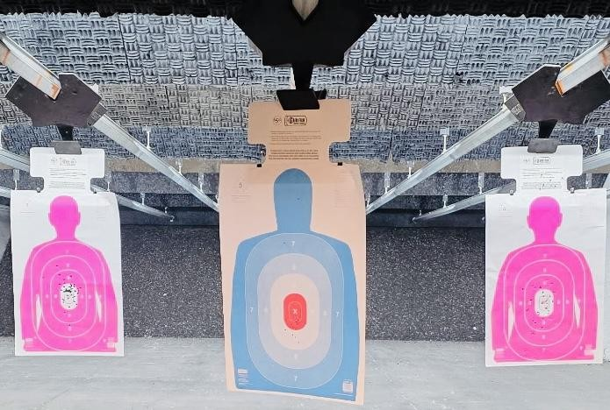
WHO? RWGC Members WHAT? Shooting at the range
WHEN? 12 Noon – 6/9/26
WHERE? Top Shot Indoor Range 5685– SE Loop 281
HOW? Bring a gun and your ammo. If you need help, RWGC member – DIANE HENDERSON or the guys that work at Top Shot are happy to help with anything from unjamming a gun to teaching you the basics of shooting. Eye and hearing protection is required. Safety 1st Contact Tricia – 903-738-7700

Americanism
Gail Apple - Chairman

Key Historical America 250 Events in June

June 2, 1865 - The American Civil War officially ends as Confederate General Edmund Kirby Smith signs surrender terms.

June 4,1919 – The U.S. Congress passes the 19th Amendment to the Constitution, granting women the right to vote.

June 5,1968 - Senator Robert F Kennedy is assassinated after winning the California presidential primary.

June 17, 1972 – The Watergate burglary occurs, leading to a major political scandal.

June 19,1865 – Enslaved African Americans in Texas are officially informed of the Emancipation Proclamation, marking the beginning of Juneteenth celebrations.

Wednesday, June 24, 11:30-2:30, 2802 Gilmer Rd, Suite 5, covered dish
Constitution Classes: Biblical Citizenship/Constitutional Defense alternately

Learn how our forefathers built a government they yearned for, that would represent to the needs of the people, based on conservative and moral values found in the bible. Call Gail Apple for info: 903 235 4149
First Responder Committee
Sandy Garrison - Chairman

Wednesday, October 28th is First Responder Day. I’m looking for volunteers to help me produce ideas to honor our Gregg County police officers, firefighters, EMTs, paramedics and 911 dispatchers on that day and other holidays through the year. If you would be willing to help me, produce ways to show love and appreciation for their bravery and sacrifice, please contact me, Sandy Garrison, at sejean275@gmail.com or text to 903-918-5167. Thank you - Sandy


Veteran Committee Sharron Fowler - Chairman
Veterans Committee Newsletter – June 2026
🇺🇸 Honoring Service, Remembering Sacrifice 🇺🇸
As we observe Memorial Day, we take time to honor and remember the brave men and women of the United States Armed Forces who made the ultimate sacrifice in service to our nation. Their courage, dedication, and selfless commitment will always be remembered. We remain deeply grateful for the freedoms we enjoy as a result of their service and sacrifice.
Longview Veterans Resource Center Update
We are pleased to report the continued growth and positive impact of the Longview Veterans Resource Center through our partnership with Operation True North. Together, we are committed to connecting Veterans and their families with valuable resources, support services, and opportunities that enhance the well-being of our Veteran community.
Plastic Bag Collection for Unhoused Veterans
We are currently accepting donations of plastic shopping bags to support a special initiative led by Ms. Elizabeth Taylor of American Legion Post 302 in Gilmer, Texas.
Ms. Taylor transforms donated plastic bags into durable sleeping mats for unhoused Veterans. These mats provide comfort, insulation, and protection from the elements.
Did you know?
- One sleeping mat measures approximately 3 feet by 6 feet
- Each mat requires approximately 700 plastic shopping bags
We encourage you to save and donate your clean plastic shopping bags. Every contribution helps provide meaningful support to a Veteran in need.
Join the Veterans Committee
If you are committed to supporting those who have served our nation, we invite you to become involved with the Veterans Committee. There are numerous opportunities to make a meaningful and lasting impact on the lives of Veterans throughout our community.
Please contact me if you are interested in serving on the Veterans Committee. There is important work to be done, and your involvement can make a difference.
Dedicated to serving the men and women who have served our nation.
With sincere appreciation, **God Bless Our Veterans. God Bless Texas. God Bless the USA** Sharron Army | ⚓ Navy | ✈️ Air Force | 🦅 Marine Corps | 🚢 Coast Guard | 🚀 Space Force | ⚔️ National Guard

American Exceptionalism


America is like no other country.
- The political structure removed a ruling monarch and designed a more perfect union with legislative, judicial, and executive branches with federal and state laws.
- Social structure is not based on a class system but on an individual’s freedoms.
- Judea-Christian values molded our free speech, right to own property, the People’s Rights, or the Bill of Rights.
Americans are allowed the freedom to think, speak, and pursue one’s own interests.
Achievements are seen based on creativity, perseverance, and the promise of opportunity.

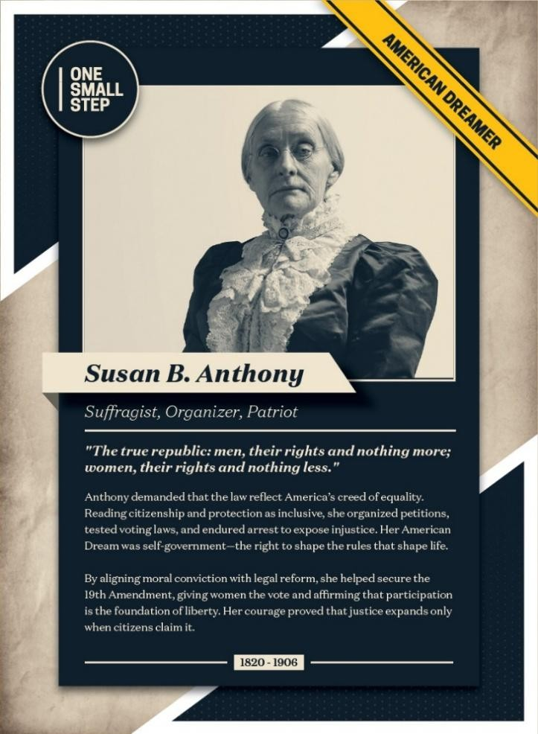






v


Republican Women In Action
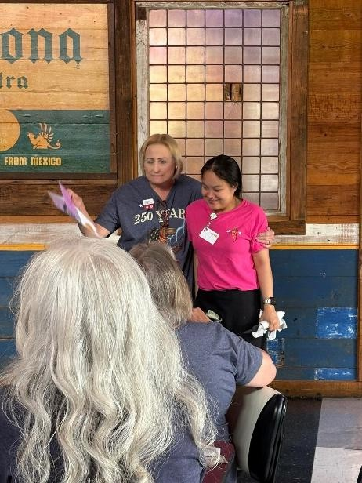
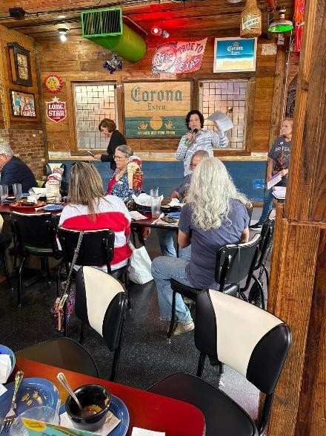
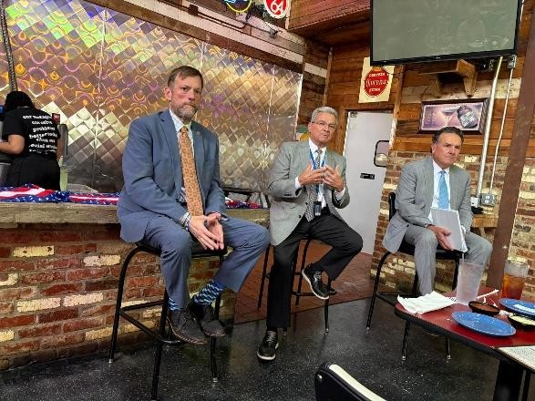
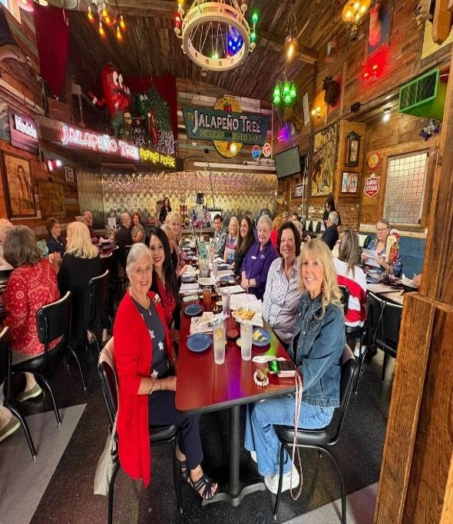
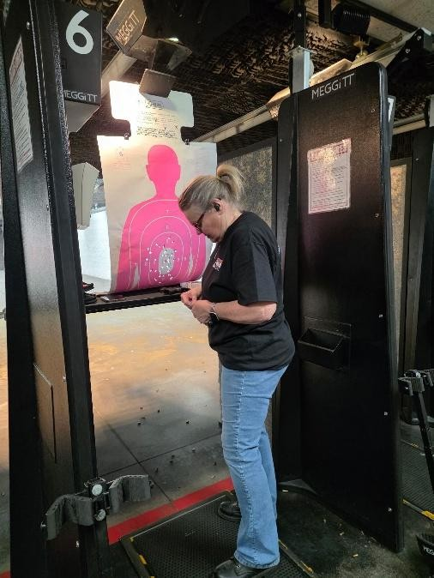


Republican Women of Gregg County 2026 Scholarship Winners
Join us at the RWGC General Meeting, 12 noon, July 15 at the Jalapeno Tree in Longview as we award these two young ladies for their accomplishments, leadership, community engagement, and passion for conservative values.


Meet Anna Tyron, 2026 graduating senior from Sabine High School. Anna has been accepted to Texas Tech in Lubbock to study mechanical engineering with later plans to enter law school. Anna won the RWGC Graduating Senior Scholarship award of $1000.

Meet Olivia Odom, 2026 graduate from Hallsville High School accepted to Baylor University to study Biology/Pre-Med with plans to become an anesthesiologist. She is the granddaughter of RWGC member, Sandy Odom. Olivia won the RWGC Member’s Family Scholarship of $1000.



QR code for access to our website!!
Please keep the following in your prayers:
PRAY FOR:
- Prayers for Sharon Clark’s brother with pancreatic cancer
- Prayers for Nancy Holly’s husband Larry, Lee Lafferty, Haskell Williamson, Jerry Gipson, & Dave Holly
- Tricia and Tyler Oxton
- Prayers for Michelle Gamboa and Isabella
- Those traveling on vacation and traveling to convention
- SAVE AMERICA Act passage
- RPT State Convention Effectiveness and Common-Sense Policies
- To all our active military on duty near Iran
- Prayers to keep our President safer to continue his work
- Party Unity in November elections

Important Dates to Remember in June and future
June 3: Exec Board Meeting GOP office 12 noon June 9: Guns & Gals
June 11-13 GOP Convention Houston June 14: Flag Day
June 17: RWGC General Meeting Program starts 12 noon June 21: Father’s Day
July 1: Executive Board meeting Gop office 12 Noon July 15: RWGC General Meeting Program Starts at Noon
July 21: Trivia & Treason w/AFP 5:30-8pm at Country Tavern
Sept 22: America 250 Lincoln/Reagan Dinner, Pinecrest Golf Club, 6pm to 8:30 pm
SAVE THE DATE!

Girls on the Go:
Get your tickets for $40 NOW for the Musical Production 1776 -Thursday -July 2 - 2pm at the Anne Dean Turk Fine Arts Center Kilgore College: https://www.texasshakespeare.com/purchase-tickets
PLAN TO JOIN US FOR THE Jun 17th GENERAL MEETING AT JALAPENO TREE PLEASE ARRIVE AT 11:30 TO ORDER LUNCH.
June 17th
Republican Party of Texas Convention Recap
Political advertising paid for by the Republican Women of Gregg County PAC. Contributions are not federal tax deductions as charitable contributions. Corporate contributions are not permitted. RWGC PAC can be contacted at P.O. Box 5, Longview, TX 75606. The information listed herein is not an endorsement of any candidate and is intended for information purposes only.

Republican Women of Gregg County
Membership Application
2026 Membership Information Date:
Please check one: $40.00 Active Membership includes Voting Privileges
$15.00 Associate Men (no Voting Privileges)
$15.00 Associate Women with Active Membership in another Republican Women’s Club (Not eligible to vote in RWGC)
Name: Birthday (xx-xx-xxxx) Spouse’s Name: Birthday (xx-xx-xxxx) Address: City: State: Zip Home Phone Cell Phone Work Phone Email Address Occupation Employer
If retired, former Occupation County Voting Precinct
Are you a member of another Republican Women’s Club? Yes No If yes, which club? Active Member in that club OR Associate Member in that club
Check if applies: Allow: RWGC use of my photo Sharing my contact info with members
OPT- IN: RWGC can post my name, email, and phone number on members only
section of the RWGC website.
I AM INTERESTED IN THE FOLLOWING COMMITTEES
Campaign Activities Fund Raising Literacy Building Membership Legislative Caring for America Telephone Outreach Publicity Other Talents, skills or interests you have
(Use back for additional information you want us to know.)
Contributions to Republican Women PAC are not deductible for tax purposes.
Checks should be made payable to RWGC PAC, P.O. Box 5, Longview, TX 75606Political advertising paid for by the Republican Women of Gregg County PAC. Contributions are not federal tax deductions as charitable contributions. Corporate contributions are not per permitted. RWGC PAC can be contacted at P. O. Box 5, Longview, Texas 75606. The information listed herein is not an endorsement of any candidate and is intended for information purposes only.
TO 2026

