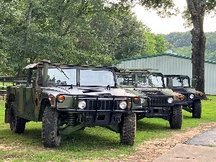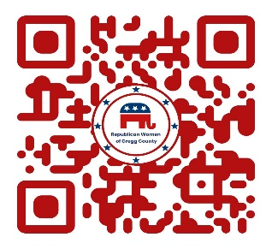
2nd Military Vehicle/Military Motorcycle Only
November 1, 2025 – Rain or Shine

Registration: 8 to 9:00 Judging: 11:00 AM Awards: 1:00 pm
Show Time: Saturday 10 to 1:00 Place: Outdoors Front of Maude Cobb Convention Center Parking Lot
*******************************************************************************************
*1st Place Trophy
* 2nd Place Trophy
*3rd Place Trophy
Door prizes, Goody Bags, Catered BBQ Lunch, Music, Wall of Heroes Display
Gun and Knife Show at Exhibit Hall 9-5 $10
Longview Arboretum and Nature Center 10-5 $5.00
Optional Indoor Veteran Appreciation Event 12-2 $45.00
Call : Jennifer Kranzman 903 445 8627
Name:________________________Address: ______________City __________Date______ Phone_______
Year: ________Make: ______________ MODEL: ___________ # Veteran____________Branch__________
E-Mail ADDRESS: __________________________ Confirmation of Registration Sent By E-mail ONLY
Pre -Registration Only: $25 OUTDOOR SHOW ONLY, $45 BOTH EVENTS, $25 To Sponsor a Veteran all Events
Make Check Payable To: RWGC Event Account Mail to: PO. Box 5 LONGVIEW, Tx 75606
In consideration of the acceptance of the right to participate, entrants, participants and spectators, by execution of the form, release and discharge of the acceptance of the right to participate, entrants, participants and spectators, by execution of the form, release and discharge RWGC and Lone Star Lug Nuts, City of Longview. representatives and anyone connected to the management or presentation of The Military Vehicle Show from any loss, damage or injury to persons, vehicles or any articles while attending and/or participating in the show. I accept full responsibility for damages to me, my family or VISITORS, IF unable to attend, no monies will be refunded, by signature below i agree to allow pictures or video of my entry outdoor show.
___________________________________________________________________ Pre-Registration Must Be Postmarked by Oct 15,2025
Signature Date Total Enclosed: $_______ Received: _________
Political advertising paid for by the Republican Women of Gregg County PAC. Contributions are not federal tax deductions as charitable contributions. Corporate contributions are not permitted. RWGC PAC can be contacted at P.O. Box 5, Longview, TX 75606. The information listed herein is not an endorsement of any candidate and is intended for information purposes only. CASH APP Payment Also Available - $republicanwomengreggco

